PLAISTOW COMMUNITY KITCHEN
Design and Data Pack
Work Experience Project — Track C: Design and Data
Project: Volunteer Booking and Stock Management System

1. Project Overview
Plaistow Community Kitchen relies on volunteers to help with its daily activities. Managing volunteer shifts and keeping track of food stock can be difficult when information is recorded manually. Volunteers may be booked for overlapping shifts, the coordinator may not know how much stock is available, and information may need to be copied between different records.
The aim of this project is to design a simple digital system that helps the kitchen organise volunteers, manage shift bookings, view the rota and monitor stock levels.
The system is being designed as a clickable Figma prototype. It will include a dashboard, volunteer list, shift bookings page, rota page and stock management page. The design should be suitable for both laptops and phones and should be easy to understand for people with different levels of technical experience.
The project follows Track C, which focuses on interface design, data modelling, prototyping and usability testing rather than building a fully functioning application.
2. Intended Users
Persona 1: Amara — Kitchen Coordinator
Age: 38
Role: Kitchen coordinator
Amara is responsible for organising volunteers and making sure the kitchen has the people and supplies it needs. She currently spends time checking shift information and keeping track of stock. She needs a system that makes this information easier to access without having to check multiple records.
Goals:
- View upcoming shifts and see which volunteers are assigned.
- Find volunteer information quickly.
- Identify shifts that may need more volunteers.
- Check stock quantities and identify items running low.
- Reduce the time spent managing information manually.
Potential difficulties:
- Keeping information up to date across different records.
- Finding information quickly when the kitchen is busy.
- Accidentally entering incorrect information or overlooking a low-stock item.
Design considerations: The dashboard should provide a clear overview, with consistent navigation and easily identifiable actions.
Persona 2: Ron — Volunteer
Age: 67
Role: Kitchen volunteer
Ron uses an older Android phone and is less confident with complicated digital systems. He needs to understand shift information without having to navigate through confusing menus or read small text.
Goals:
- View available shifts and their times.
- Understand which tasks need volunteers.
- Navigate the system using clear labels.
- Receive understandable feedback after taking an action.
Potential difficulties:
- Small text and buttons that are difficult to tap.
- Confusing instructions or technical language.
- Pages that do not display properly on an older phone.
Design considerations: The interface should use readable text, clear buttons, straightforward navigation and a layout that works on smaller screens.
3. Requirements Analysis — MoSCoW
MoSCoW is a method used to prioritise requirements by dividing them into Must have, Should have, Could have and Won't have for this version.
Must Have
- A dashboard showing an overview of volunteers, shifts and stock.
- A volunteer page displaying volunteer information.
- A shift bookings page showing booking information.
- A rota page displaying shift dates, times and assigned volunteers.
- A stock management page showing items and quantities.
- Clear navigation between the main pages.
- A layout that is understandable and readable for the intended users.
Should Have
- A clear way to begin adding a volunteer.
- A clear way to begin creating or managing shift bookings.
- Low-stock warnings that are easy to identify.
- Consistent buttons, colours and layouts across the pages.
- A design that can be viewed on a phone as well as a laptop.
Could Have
- Search and filtering for volunteers and stock items.
- Sorting the rota by date or time.
- Additional summaries showing shifts that need volunteers.
- More detailed stock reports.
Won't Have in This Prototype
- A live database that permanently stores information.
- A complete login and account system.
- Automatic notifications to volunteers.
- Fully working booking validation and stock updates.
These features could be considered if the design were developed into a functioning application in the future.
4. User Journeys
A user journey describes the steps someone would take to complete a task using the proposed system.
Journey 1: A Volunteer Books a Shift
User: Volunteer
Goal: Find and book a suitable shift.
- The volunteer opens the system on their phone or laptop.
- They navigate to the shift bookings page.
- They review the available shift dates, times and roles.
- They select a suitable shift and begin the booking process.
- They review the information and confirm their intended booking.
- The system should display a confirmation and update the booking information.
Design consideration: The process should be straightforward and provide clear feedback. In a fully functioning system, the software should also check for overlapping shifts and available capacity before confirming the booking.
Prototype limitation: The Figma design demonstrates the intended process. It does not automatically save or validate bookings unless that functionality is separately implemented.
Journey 2: The Coordinator Checks Tonight's Rota
User: Kitchen coordinator
Goal: Find out which volunteers are working that evening.
- Amara opens the coordinator dashboard.
- She selects “Tonight's Rota” from the navigation menu.
- She reviews the shift times, roles and assigned volunteers.
- She identifies any shifts that may need additional volunteers.
- If necessary, she navigates to the volunteer or booking page to review further information.
Design consideration: The rota should be easy to scan, with shift times and volunteer names clearly displayed. The coordinator should not have to search through unrelated information to find the rota.
Journey 3: The Coordinator Updates Stock
User: Kitchen coordinator
Goal: Record a stock quantity of 12 tins of tomatoes.
- Amara opens the Stock Management page.
- She locates the tomatoes entry.
- She selects the relevant edit or update action.
- She enters the quantity as 12 and checks that the unit is recorded as tins.
- She saves the change.
- She checks that the displayed quantity and stock status are correct.
Design consideration: The quantity and unit should be clearly labelled to reduce mistakes.
Prototype limitation: The design shows how a stock update should work. The prototype does not permanently save changes unless working data functionality is added.
5. Data Model
A data model describes the information a system needs to store and how different records relate to each other.
The proposed system uses four main entities: Volunteer, Shift, Booking and Stock Item.
Entity 1: Volunteer
Field | Data type | Purpose
volunteer_id (Primary Key) | Integer | Unique identifier for each volunteer
name | Text | Volunteer’s name
contact_details | Text | Contact information, where required
availability | Text | General availability of the volunteer
Entity 2: Shift
Field | Data type | Purpose
shift_id (Primary Key) | Integer | Unique identifier for each shift
shift_date | Date | Date of the shift
start_time | Time | Start time
end_time | Time | Finish time
role | Text | Task or role required
capacity | Integer | Maximum number of volunteers
Entity 3: Booking
Field | Data type | Purpose
booking_id (Primary Key) | Integer | Unique identifier for each booking
volunteer_id (Foreign Key) | Integer | Links the booking to a volunteer
shift_id (Foreign Key) | Integer | Links the booking to a shift
booking_status | Text | Records whether the booking is requested, confirmed or cancelled
Entity 4: Stock Item
Field | Data type | Purpose
stock_item_id (Primary Key) | Integer | Unique identifier for each stock item
item_name | Text | Name of the food or supply
quantity | Number | Current recorded quantity
unit | Text | Unit used, such as tins, packets or kilograms
low_stock_threshold | Number | Quantity at which the item should be flagged as low stock
Relationships Between Entities
A volunteer can have multiple bookings over time. A shift can also have multiple bookings, depending on its capacity. Each booking links one volunteer to one shift.
The Stock Item entity is separate because stock quantities are not directly linked to individual shift bookings in this basic design.
Primary keys uniquely identify records. Foreign keys link related records together. For example, the volunteer_id in a booking identifies which volunteer made the booking.
A complete system should check that volunteers are not booked into overlapping shifts and that a shift does not exceed its maximum capacity.
6. Pseudocode
Pseudocode describes the steps a system should follow using simple, programming-like instructions. It helps explain the intended logic without requiring a specific programming language.
Preventing Double Bookings
START booking request

Find the volunteer and requested shift.

IF the volunteer or shift does not exist
Display an error message.
ELSE
Check the volunteer's existing confirmed bookings.

IF an existing booking overlaps the requested shift
Do not confirm the new booking.
Display an overlap warning.

ELSE IF the shift has reached its capacity
Do not confirm the booking.
Display a message that the shift is full.

ELSE
Confirm the booking.
Display a confirmation message.
END IF
END IF

END
This process is intended to reduce scheduling conflicts and prevent shifts from accepting more volunteers than they can accommodate.
Low-Stock Warning
FOR each stock item

IF the quantity is less than or equal to
the low-stock threshold

Display a low-stock warning.

ELSE
Display the normal stock status.
END IF

END FOR
This process compares each item's current quantity with its low-stock threshold. If the quantity reaches or falls below that threshold, the system should flag the item so the coordinator can decide whether more supplies are needed.
These are proposed rules for a functioning system. The current visual prototype does not automatically perform these checks.
7. Accessibility and Usability
Accessibility means designing a system so that people with different abilities, devices and levels of technical experience can use it.
The design should consider the following principles.
Readable Text
Text should be large enough to read comfortably, especially on phone screens. A practical target is around 16 pixels for normal body text where possible.
Colour Contrast
Text should have sufficient contrast against its background. The design should aim to meet the WCAG AA contrast guidelines.
Colour should not be the only way of communicating information. For example, low stock should have a visible text label as well as a colour indicator.
Clear Buttons and Labels
Buttons should use understandable labels such as “Add Volunteer” or “Stock Management”. Users should be able to understand what an action does before selecting it.
Interactive areas should also be large enough to tap comfortably on a phone.
Consistent Navigation
Navigation should remain consistent across the different pages. Keeping the same labels and layout helps users learn where information is located.
Simple Language
Instructions should avoid unnecessary technical terms. Forms should have clear labels, and error messages should explain what went wrong and how the user can correct it.
Responsive Layout
The design should remain usable on both laptops and phones. Important information should not become too small or disappear when viewed on a narrower screen.
Feedback
A functioning system should provide feedback when users complete actions, such as confirming a booking or saving a stock update. If an action fails, the message should explain the problem clearly.
These principles are particularly important because the intended users may have different levels of confidence using technology.
8. Data Protection and Privacy
A real volunteer management system would process personal information, including names, contact details and shift bookings. This information should be handled responsibly under applicable UK data protection law, including the UK GDPR and the Data Protection Act 2018.
The organisation should identify a lawful basis for processing personal information and explain to volunteers why their information is collected and how it will be used.
Only information that is necessary for the system's purpose should be collected. For example, if a particular contact detail is not needed to organise shifts, there should be a clear reason before collecting it.
Access to personal information should be restricted to authorised people who need it for their work. The system should use appropriate security measures to reduce the risk of unauthorised access, loss or disclosure.
Information should be kept accurate and should not be stored for longer than necessary. The organisation should also have appropriate procedures for correcting information and responding to data protection requests.
Personal information should not be displayed publicly or included in screenshots shared outside the project without appropriate permission. Example names used in the prototype should be treated as illustrative information rather than verified volunteer records.
If the design were developed into a real system, further consideration would be needed for account security, access permissions, backups and data retention.
9. Questions for the Client
The following questions could be used to confirm the kitchen's needs before developing the design further.
- How do volunteers currently sign up for shifts?
- Who is responsible for adding, changing or cancelling bookings?
- How many volunteers are normally needed for each shift?
- Should the system prevent volunteers from booking overlapping shifts?
- What information about each volunteer needs to be stored?
- Which food and supply items need to be tracked?
- What units are used to measure stock, such as tins, packets or kilograms?
- Who is allowed to update stock quantities?
- How should low-stock thresholds be decided?
- Should volunteers be able to see the full rota or only their own shifts?
- Which devices do the coordinator and volunteers normally use?
- Are there any accessibility needs the design should consider?
- What problems take the most time when managing shifts and stock manually?
- What would make the proposed system easier to use than the current process?
These questions should be used to gather genuine client feedback. Their answers should be recorded separately after the client has responded.
10. Success Criteria
Success criteria are measurable targets used to evaluate whether the design meets its intended purpose.
Criterion 1 — Navigation: Users should be able to navigate between the Dashboard, Volunteers, Shift Bookings, Tonight's Rota and Stock Management screens using the prototype's navigation.
Criterion 2 — Access to the rota: A coordinator should be able to reach Tonight's Rota from the dashboard in no more than four clicks.
Criterion 3 — Readability: The main information should remain readable when the design is viewed at a phone-sized screen width.
Criterion 4 — Low-stock identification: Low-stock items should be identifiable through a clear warning or text label rather than colour alone.
Criterion 5 — Usability: Two people should be asked to try agreed tasks using the prototype. Their actual results and feedback should be recorded to identify any difficulties.
The results should be evaluated after testing. A criterion should not be marked as achieved until there is evidence to support that conclusion.
11. Current Project Limitations and Next Steps
The current project is a Figma prototype designed to demonstrate the proposed interface and user journeys. It is not a fully functioning application.
The prototype does not automatically store bookings, update a database, enforce shift capacity or permanently save stock changes. These would require additional implementation.
The next steps are to complete the remaining design evidence, carry out usability testing with two people, record at least 12 test cases, make any appropriate design improvements and evaluate the final prototype against the success criteria.
Testing results must reflect what actually happened. Features that are not implemented should be recorded honestly rather than being described as working.
The completed project should be accompanied by screenshots of the Figma screens, evidence of user feedback, a test log, a user guide and a final evaluation. Career research and reliable sources should also be added where required by the work experience brief.
Overall aim: To produce a clear, accessible and practical design that demonstrates how Plaistow Community Kitchen could improve volunteer coordination and stock management through a simple digital system.

12. Figma Prototype Screenshots
Figure 1: Coordinator Dashboard
The following screenshots show the five main screens designed for the Plaistow Community Kitchen prototype. The screens provide navigation for the coordinator dashboard, volunteer information, shift bookings, the rota and stock management.
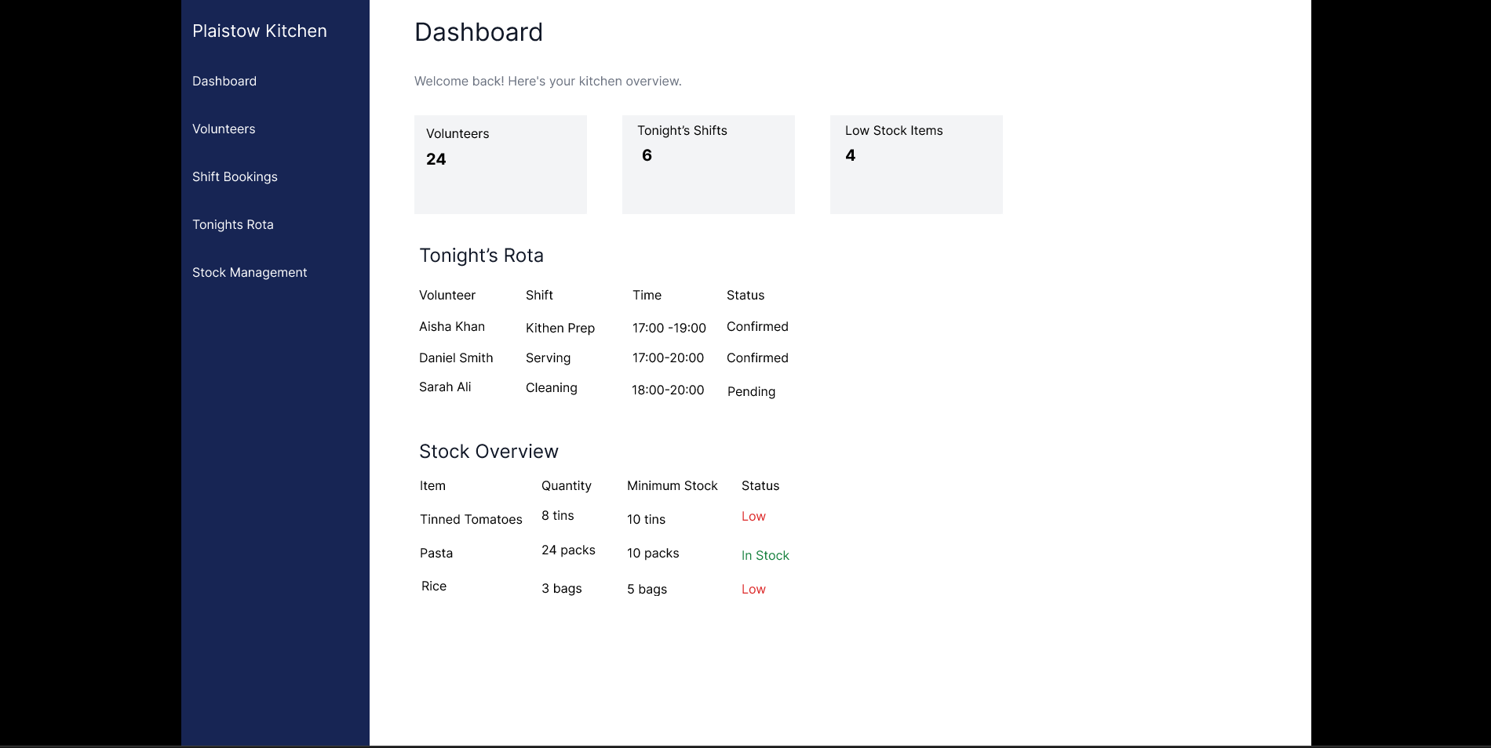
Figure 2: Volunteers
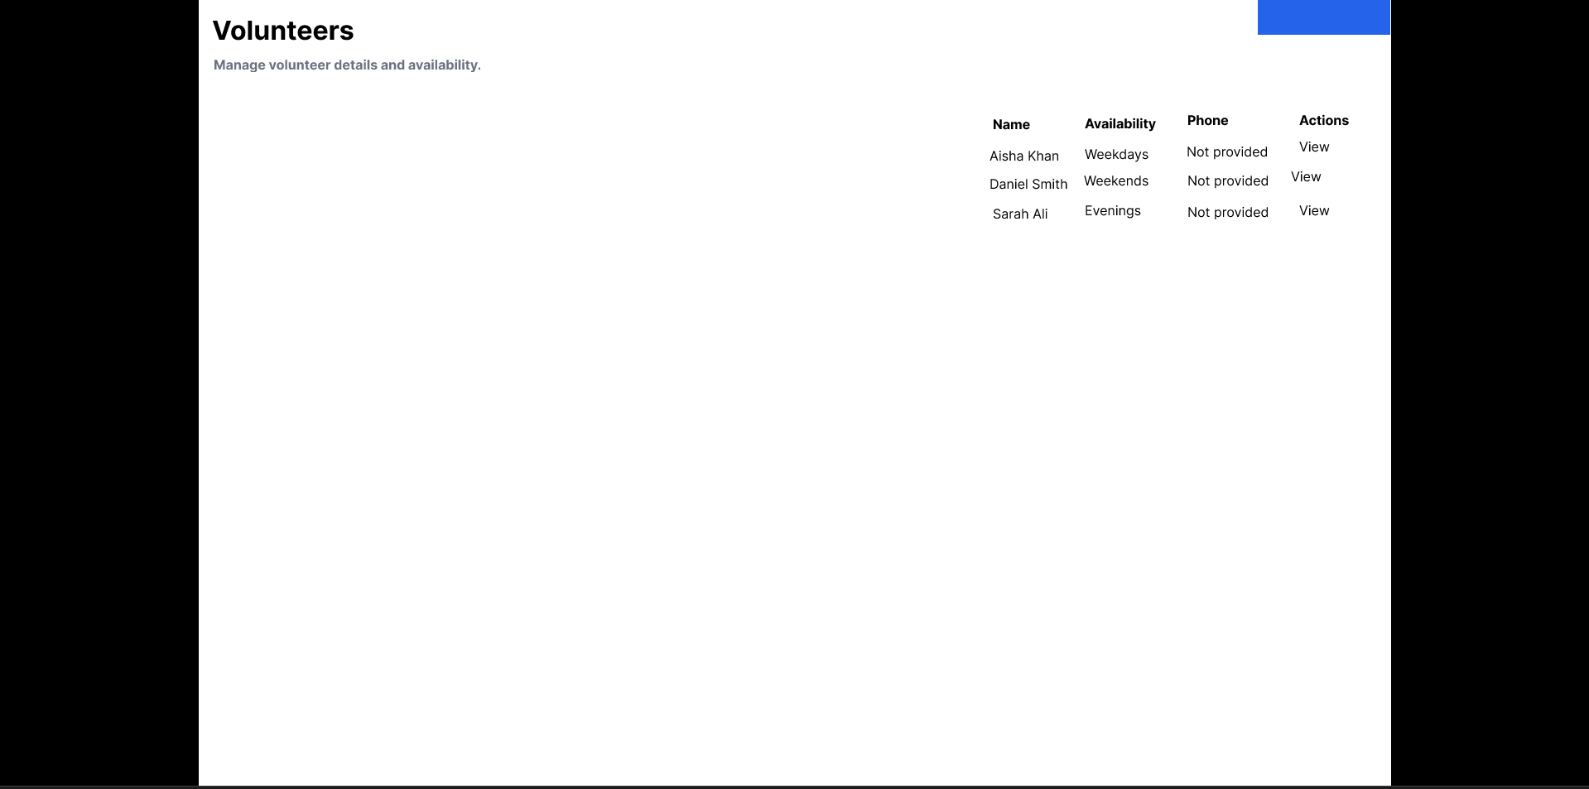

Figure 3: Shift Bookings
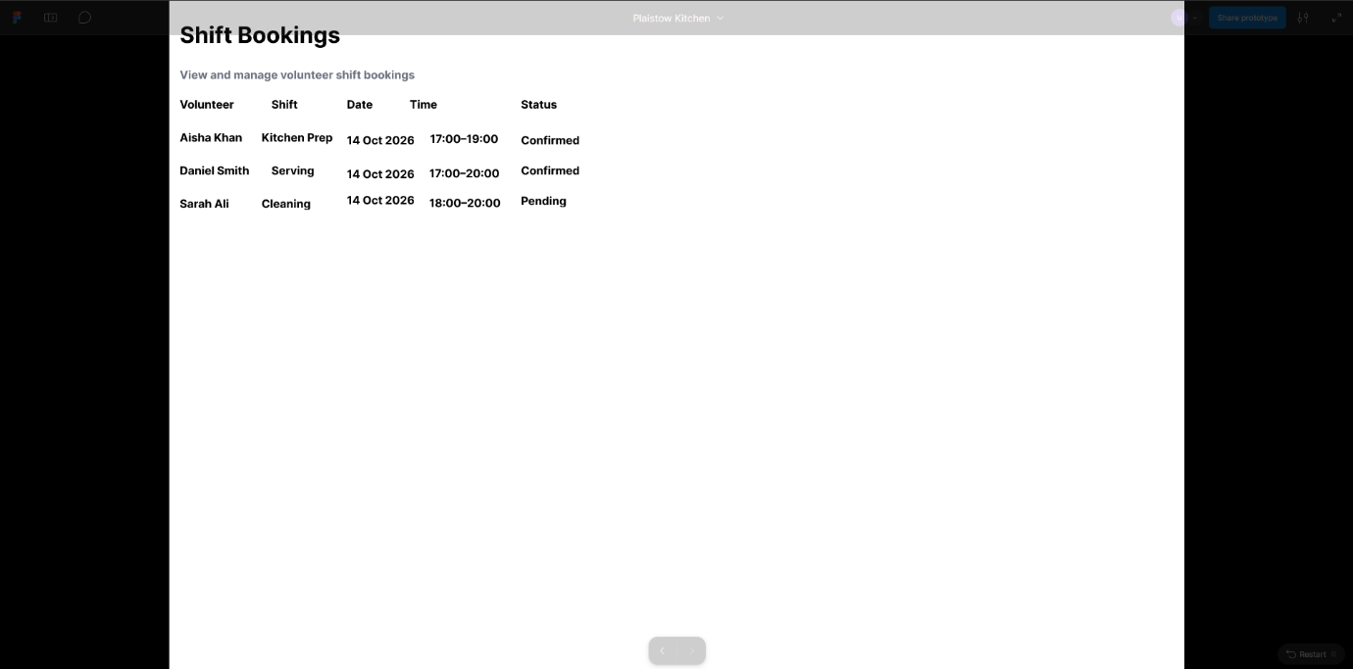
Figure 4: Tonight's Rota
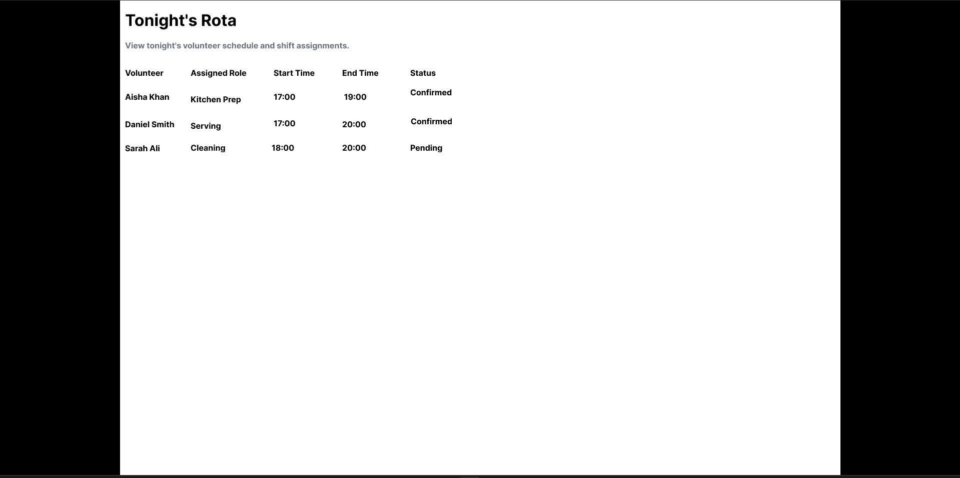

Figure 5: Stock Management
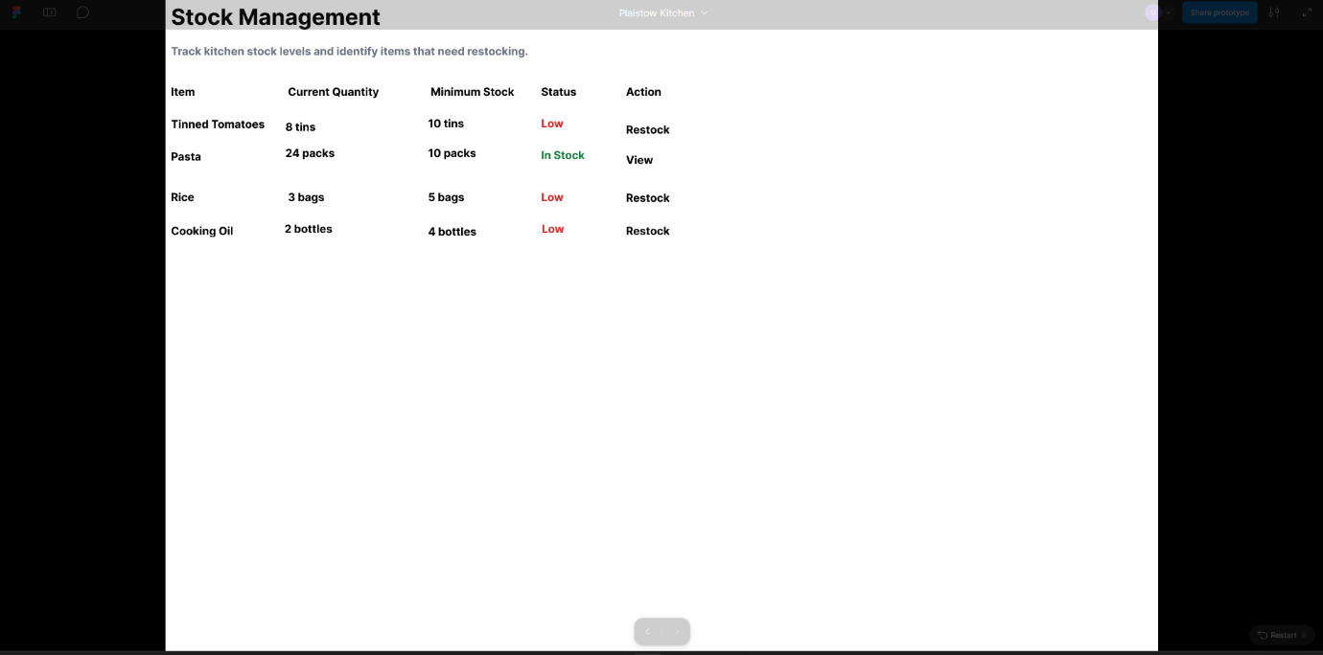
13. Project Plan
The project was organised into stages to make sure the prototype could be designed, tested and documented within the work experience placement.
Stage | Tasks | Planned time | Status
1. Research and discovery | Understand the client's problems, identify user needs and research suitable computing careers. | Day 1 | Partially completed
2. Requirements and planning | Identify essential features, create user journeys and plan the project. | Day 1 | Partially completed
3. Data and interface design | Design the data model, wireframes and accessibility features. | Day 2 | Partially completed
4. Prototype development | Build the five Figma screens and connect the navigation. | Days 2–3 | Completed
5. Testing and improvements | Test the prototype, collect feedback from two people and make improvements. | Day 4 | Not completed
6. Final documentation | Complete the user guide, case study, evaluation and presentation. | Day 5 | Not completed

14. Project Risks
Risk 1: The prototype may be confusing for users.
Some volunteers may not be confident using technology, particularly on older phones. If the navigation or buttons are unclear, users could struggle to book shifts or find information.
How to reduce the risk: Use clear labels, simple navigation, readable text and large buttons. Ask two people to try the prototype and use their feedback to identify improvements.
Risk 2: Incorrect or incomplete information could cause problems.
If volunteer details, shift bookings or stock quantities are entered incorrectly, the kitchen could experience double bookings or run out of supplies unexpectedly.
How to reduce the risk: Use suitable data types and validation rules in the planned data model. Test invalid entries and explain that the prototype is a demonstration rather than a live system connected to real kitchen records.
15. Prototype Testing Plan
The prototype will be tested to check that the navigation is clear, the screens display correctly and the main features make sense to users. Testing will include normal actions and situations where information is missing or incorrect. Since this is a Figma prototype, the tests check the screens and clickable interactions rather than a real database.
Test | Action | Expected result | Actual result | Pass/Fail
1 | Open the prototype in Present mode. | The dashboard displays correctly. | To be tested | Pending
2 | Click Volunteers in the sidebar. | The Volunteers screen opens. | To be tested | Pending
3 | Click Shift Bookings in the sidebar. | The Shift Bookings screen opens. | To be tested | Pending
4 | Click Tonight's Rota in the sidebar. | The rota screen opens. | To be tested | Pending
5 | Click Stock Management in the sidebar. | The stock screen opens. | To be tested | Pending
6 | Navigate back to the dashboard. | The dashboard opens successfully. | To be tested | Pending
7 | Check the text on each screen. | Text is readable and does not overlap other elements. | To be tested | Pending
8 | View the prototype at a phone-sized screen. | The content remains usable and readable. | To be tested | Pending
9 | Look for a shift-booking option for the same volunteer and shift. | The design or planned system should prevent duplicate bookings. | To be tested | Pending
10 | Consider entering an invalid or missing volunteer name. | The planned system should reject incomplete or invalid information. | To be tested | Pending
11 | Check the stock screen for an item with a low quantity. | Low stock should be easy to identify. | To be tested | Pending
12 | Check whether buttons and navigation labels are clear. | Users should understand where each control will take them. | To be tested | Pending
Completed Prototype Tests
Test 1: Open Prototype
Actual result: The dashboard opened correctly in Present mode.
Result: Pass
Test 2: Volunteers Navigation
Actual result: The Volunteers screen opened correctly.
Result: Pass
Test 3: Shift Bookings Navigation
Actual result: The Shift Bookings screen opened correctly.
Result: Pass
Test 4: Rota Navigation
Actual result: The Tonight's Rota screen opened correctly.
Result: Pass
Test 5: Stock Navigation
Actual result: The Stock Management screen opened correctly.
Result: Pass
Test 6: Return to Dashboard
Actual result: The dashboard could be reached using the sidebar.
Result: Pass
Test 7: Readability and Layout
Actual result: The text was readable and no overlapping elements were identified.
Result: Pass
Test 8: Phone-Sized View
Actual result: The prototype was checked at a phone-sized view and appeared usable.
Result: Pass
Tests Still Outstanding
Tests involving duplicate bookings, invalid entries, low-stock warnings and button clarity still require checking. The Figma prototype does not automatically validate database entries or save real bookings, so these functions cannot be treated as working features.

Testing limitation: Figma demonstrates the interface and its clickable navigation. It does not automatically save bookings, validate database entries or update stock quantities unless these behaviours have been specifically prototyped. These functions would need further development in a real system.
16. Computing Career Research
1. UX/UI Designer
A UX/UI designer creates digital interfaces that are easy to understand and use. They plan layouts, buttons, navigation and accessibility features. This role is relevant to my project because I designed screens for the Plaistow Community Kitchen prototype.
2. Software Developer
A software developer designs, builds and maintains computer programs and applications. They may use programming languages to create features, fix errors and make sure software works correctly. This career would be relevant if the Figma prototype were developed into a working application.
3. Data Analyst
A data analyst examines information to identify patterns and help organisations make decisions. They may use spreadsheets, databases and data visualisation tools. This role relates to the project because accurate volunteer, booking and stock information would help the kitchen organise its activities.
4. Cyber Security Analyst
A cyber security analyst helps protect computer systems, networks and information from threats. Their work can include monitoring risks, investigating security incidents and recommending protective measures. This role relates to the project because volunteer information should be handled securely and personal data should only be accessible to appropriate people.
Career Reflection: UX/UI Designer
Of the four careers researched, UX/UI design is particularly relevant to this project because it involves creating interfaces that people can use without difficulty. For the Plaistow Community Kitchen prototype, I designed five screens covering the dashboard, volunteers, shift bookings, the rota and stock management. When designing these screens, I needed to consider clear navigation, readable text and the needs of volunteers who may not be confident with technology. I learned that designing a system is not just about making it look attractive; it also needs to help users complete tasks efficiently. Testing the prototype with other people would help identify confusing features and areas for improvement. This project has helped me understand how user-centred design can solve practical problems for an organisation.
17. Research Sources
- National Careers Service — Software Developer
https://nationalcareers.service.gov.uk/job-profiles/software-developer
Used to research software development responsibilities, skills, salaries and routes into the career.
- National Careers Service — Computing, Technology and Digital Careers
https://nationalcareers.service.gov.uk/explore-careers/all-careers?jobCategories=computing-technology-and-digital
Used to explore different computing careers and compare their responsibilities.
- JobHelp — Digital and Tech Careers
https://jobhelp.campaign.gov.uk/sectors-recruiting/digital-and-tech/
Used to learn about the range of careers available in the digital and technology sector.
18. Examples of Computing Job Vacancies
1. UX/UI Designer — Ecosurety
- Location: Bristol
- Salary: £50,000 per year
- Type: Permanent
- Advertised: 7 October 2026
- Skills relevant to the role: Interface design, creativity and making digital products easy to use.
- Vacancy listing: https://www.cv-library.co.uk/ui-ux-jobs
2. Software Developer — Tilo Consulting
- Location: Chippenham
- Salary: £40,000–£50,000 per year
- Type: Permanent
- Advertised: Four days before the research date.
- Skills relevant to the role: Programming, problem-solving and developing software.
- Vacancy listing: https://www.cv-library.co.uk/software-developer-jobs-in-united-kingdom
3. Data Analyst — Catalyst
- Location: Gateshead
- Salary: £50,000–£80,000 per year
- Type: Permanent
- Advertised: Five days before the research date.
- Skills relevant to the role: Analysing information, identifying patterns and communicating findings.
- Vacancy listing: https://www.cv-library.co.uk/all-data-analyst-jobs
4. Cyber Security Engineer — Seetec
- Location: Hockley, Essex
- Salary: £49,000–£52,500 per year
- Type: Permanent; hybrid or remote working may be considered.
- Advertised: 30 September 2026.
- Skills relevant to the role: Protecting computer systems, identifying security risks and supporting cyber security measures.
- Vacancy listing: https://www.cv-library.co.uk/cybersecurity-jobs
Comparison
These vacancies demonstrate that computing offers different career paths. UX/UI design focuses on user experience, software development focuses on building applications, data analysis focuses on interpreting information, and cyber security focuses on protecting systems. Each role requires problem-solving and communication, but the technical skills differ.
19. User Guide — Plaistow Community Kitchen Prototype
Introduction
The Plaistow Community Kitchen prototype is a visual demonstration of a system intended to help kitchen coordinators manage volunteers, shift bookings, the rota and stock information.
1. Opening the Dashboard
Open the prototype in Figma Present mode. The dashboard provides an overview of volunteers, shifts and low-stock items.
2. Viewing Volunteers
Select Volunteers from the sidebar to view the example volunteer records. The screen demonstrates how volunteer information could be organised in one place.
3. Viewing Shift Bookings
Select Shift Bookings to view the example booking information. In a completed system, this section could help coordinators organise shifts and identify booking conflicts.
4. Checking the Rota
Select Tonight's Rota to view the example shift rota. This would help the coordinator see which volunteers are scheduled to work.
5. Checking Stock
Select Stock Management to view example stock records. Low-stock information could help the kitchen identify items that need replenishing.

Important Information
This is a clickable design prototype, not a fully functioning application. The screens use example information and do not currently represent a live kitchen database. Changes to bookings and stock quantities are not automatically saved.
Conclusion
The prototype demonstrates how a simple, clearly organised interface could help Plaistow Community Kitchen manage its daily activities more efficiently.
20. Project Case Study — Plaistow Community Kitchen
The Problem
Plaistow Community Kitchen needs a simpler way to organise its volunteers, shift bookings and stock. Managing this information manually can make it difficult to identify booking conflicts, check the rota and know which supplies are running low.
The Aim
The aim of this project was to design a simple prototype that could help the kitchen organise its information more clearly. The interface needed to be suitable for users with different levels of technical experience.
My Approach
I created a Figma prototype containing five main screens: Coordinator Dashboard, Volunteers, Shift Bookings, Tonight's Rota and Stock Management. I connected the navigation so users could move between the screens. I also prepared a data model covering volunteers, shifts, bookings and stock items.
Design Decisions
I used a consistent sidebar to make navigation easier and organised information into separate screens. Tables were used to present example records clearly. The design also considered readability and simple navigation for users who may not be confident with technology.
Limitations
The prototype demonstrates the intended interface but is not a fully functioning application. It does not have a connected database, automatically prevent duplicate bookings or update stock quantities. These features would need to be developed and tested before the system could be used by the kitchen.
Future Improvements
Future work could include developing a working database, adding validation to prevent duplicate bookings, introducing automatic low-stock warnings and testing the interface with volunteers and coordinators.
Conclusion
This project helped me understand how computing can be used to address practical organisational problems. It also showed me the importance of planning, user-friendly design, data organisation and testing when developing a digital solution.
21. Evaluation Against Success Criteria
The prototype was designed to make information about volunteers, shift bookings, the rota and stock easier to organise. The following criteria will be used to evaluate the design.
Success criterion | How it will be measured | Current status
1. Users can navigate between the five main screens. | Check each sidebar link in Figma Present mode. | Navigation has been connected; final testing is still required.
2. Volunteer information is organised clearly. | Check whether the Volunteers screen presents example records in a readable format. | Designed; user feedback is still required.
3. Shift information is easy to find. | Check whether the Shift Bookings and Tonight's Rota screens are understandable. | Designed; user feedback is still required.
4. Low stock can be identified easily. | Check whether stock information and low-stock items are clearly displayed. | Designed; further testing is required.
5. The interface is suitable for different users. | Ask two people to review or try the prototype and record their feedback. | Not yet evaluated with two users.
Overall Evaluation
The prototype provides a visual starting point for a system that could help Plaistow Community Kitchen organise its information. The five screens separate the main tasks and provide consistent navigation. However, the prototype has not yet been fully evaluated against all five success criteria. User testing is needed to identify confusing areas and determine whether the design meets the needs of the intended users.
The prototype also has technical limitations because it does not use a live database or automatically process bookings and stock changes. Further development would be required before it could be used as a real service.
Participant 1
- Feedback: The participant found the navigation easy to understand.
- Problems identified: The participant did not find anything confusing.
- Suggested improvement: Make low-stock items stand out more clearly so the coordinator can identify supplies that need replenishing quickly.
Participant 2
- Feedback: The participant also found the navigation easy to understand.
- Problems identified: The participant did not identify any confusing elements.
- Suggested improvement: Add clearer visual indicators, such as warning colours or labels, to highlight stock items that are running low.
Findings and Improvements
Both participants found the prototype easy to navigate and did not report any confusing elements. This suggests that the consistent sidebar and separate screens help users find the information they need.
One possible improvement is to make low-stock items more noticeable by using clear warning labels and contrasting colours. This could help coordinators identify supplies that need replenishing more quickly. The stock screen could also include a clear indication of which items require attention.
These improvements are recommendations based on the prototype design. They should be implemented and tested before concluding that they improve usability.
23. README — Plaistow Community Kitchen
Project Overview
This project is a Figma prototype designed to demonstrate how Plaistow Community Kitchen could organise volunteer information, shift bookings, the rota and stock records.
Features
- Coordinator dashboard showing an overview of the system.
- Volunteer records displayed in a table.
- Shift bookings screen.
- Rota screen for viewing scheduled volunteers.
- Stock management screen for viewing stock information.
- Clickable sidebar navigation between the five screens.
How to View the Prototype
- Open the Plaistow Kitchen Figma project.
- Select Present to launch the prototype.
- Use the sidebar to navigate between the screens.
Tools Used
- Figma — interface design and clickable prototype.
- Microsoft Word — project documentation.
- Microsoft PowerPoint — project presentation.
Limitations
This is a visual prototype using example information. It does not include a live database, real user accounts, automatic booking validation or automatic stock updates.
Future Development
Further development could add database integration, secure user accounts, booking conflict prevention, stock alerts and additional usability testing.
Project Status
The five main screens have been designed and the sidebar navigation has been checked. Further testing, feedback documentation and final review are required before the project can be considered complete.

